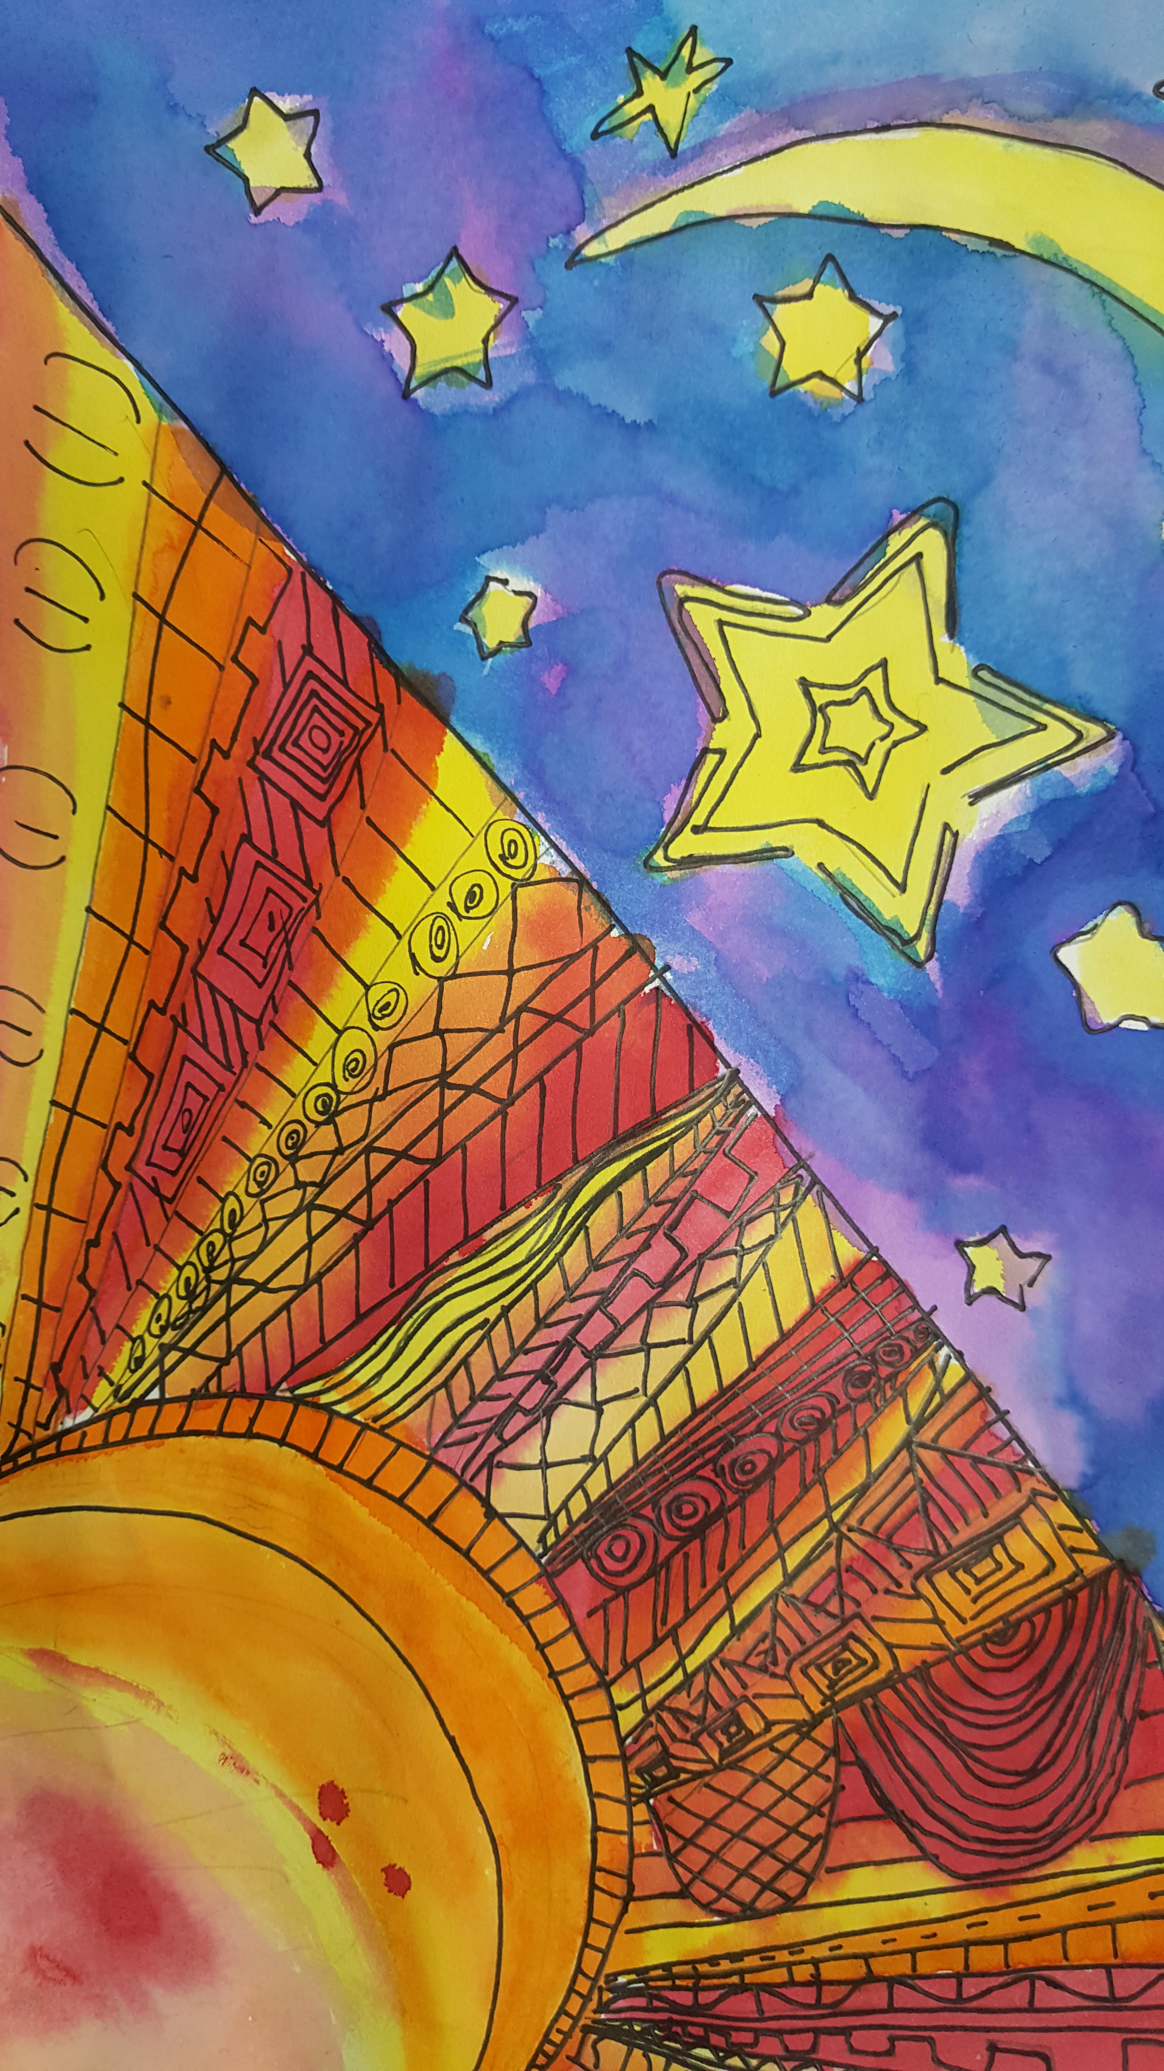

5th Graders are finishing their artwork for the musical Dusk to Dawn. This is a student choice project. They are using the theme of the musical and are all using liquid water color but they can make any mages they want. I am sure they will all look beautiful together.

4th Graders are almost done with a famous Missourian choice project. They were able to write a proposal and pick what medium they were going to work with for their project. I am impressed with how much creativity is expressed during this project.

3rd Graders are beginning a new unit on African art. They will be focusing on the art from Ghana. We read a folk tale about Anansi the spider. They will be making a pretend fabric using printmaking and different symbols that are used in their fabrics.

2nd Grade just finished a mash-up project. This project included many different concepts such as secondary colors, printmaking, relief and still life. They are very colorful and fun to put together.

1st Graders will be starting a new project based on the artist Matisse. We will be reading about Matisse and how he managed to create art even when he lost the ability to paint. We will be creating a still life out of cut paper just like he did.

Kindergarteners have been making works inspired by stories based on Pete the Cat. Since it is spring, it seemed appropriate to have Pete with an umbrella. We also are finishing the pictures by making it rain with watercolor. We are learning how crayons ‘resist’ water and how we can use gravity to create art.

Around town:

The Queeny Park all district art show will be on April 22 & 23rd this year. It is open to the public from 10 – 4 p.m. on Saturday and 12-4 on Sunday. It includes artwork from every school in Parkway school district. Each student that has an artwork from Henry will receive an invitation. All are welcome to attend whether a student is in the art show or not.

APRIL 2017

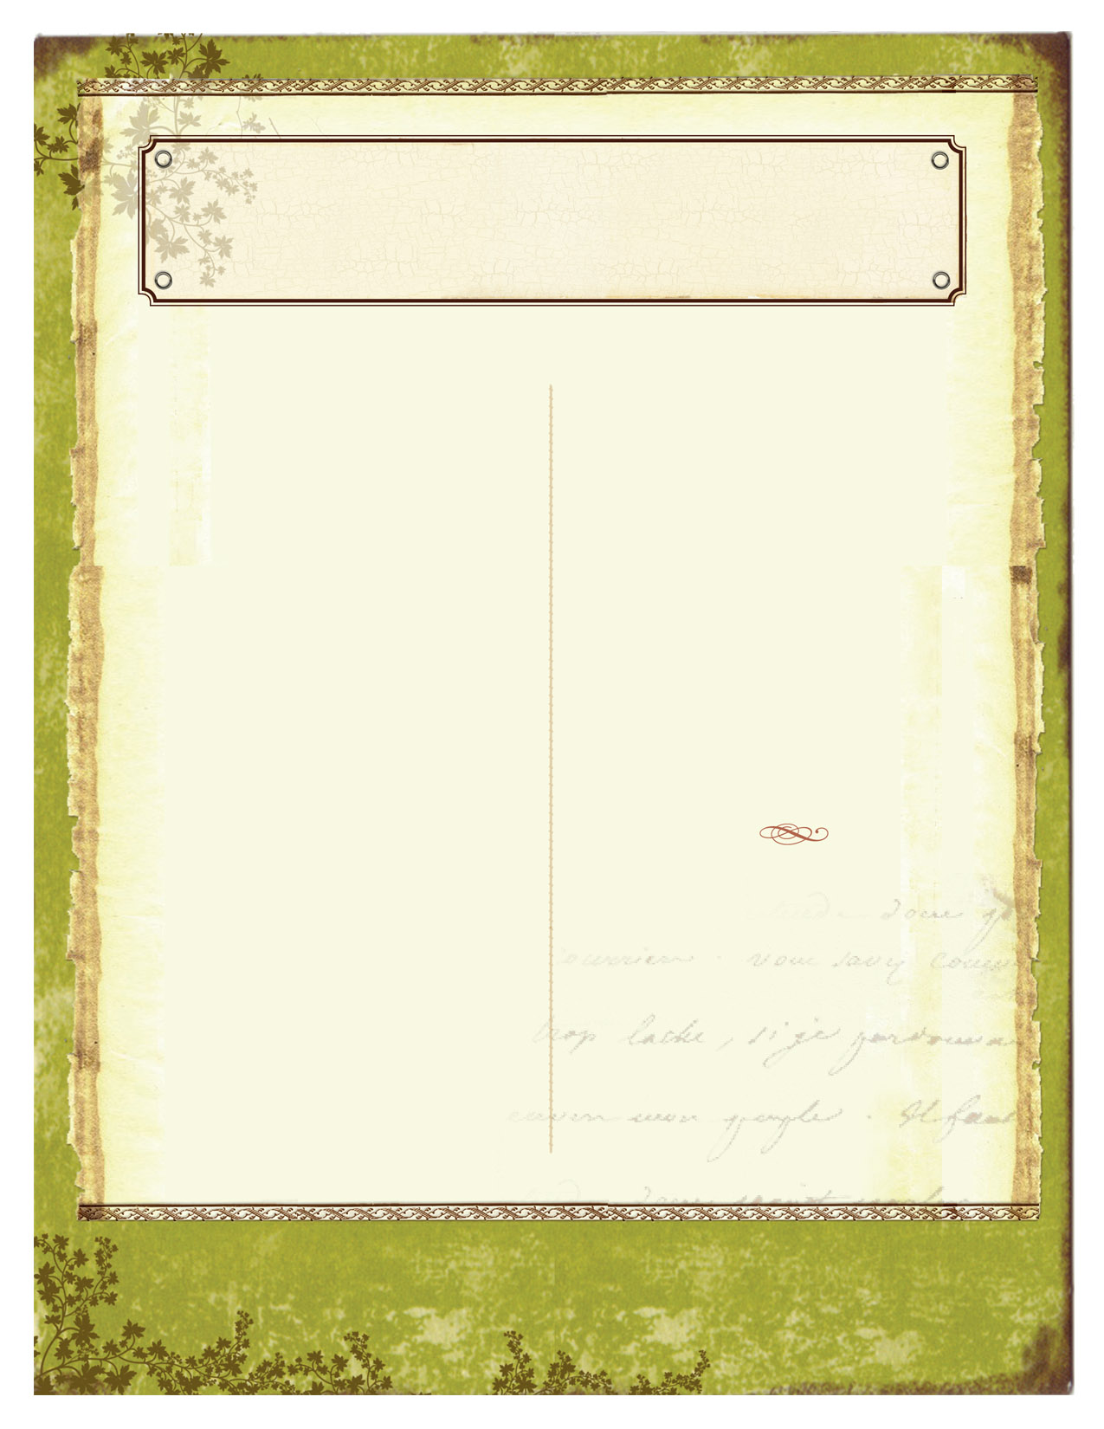

The Bulldog Art Room News

CREATIVITY. IMAGINATION. FUN.

VOL. #3 ISSUE #4